# COLLEGE OF BUSINESS, LAW & GOVERNANCE



**GROUP TASK COVER SHEET**

|  |  |  |  |  |  |  |  |  |  |
| --- | --- | --- | --- | --- | --- | --- | --- | --- | --- |
| *Students*  *Please sign, date and attach cover sheet to front of written assessment task OR*  *submit as a separate document for non-written assessment task.*  *A cover sheet is to be completed for each assessment task.* | | | | | | | | | |
| **SUBJECT CODE** |  | | | | | | | | |
| **STUDENT FAMILY NAME** | **Student Given Name** | **JCU Student Number** | | | | | | | |
| i. Chen | Cecilie | 1 | 3 | 3 | 6 | 9 | 7 | 6 | 8 |
| ii. Harkov | Robert | 1 | 3 | 3 | 3 | 8 | 1 | 5 | 6 |
| iii. Malkannagari | Udaya Bhaskar Reddy | 1 | 3 | 3 | 6 | 8 | 1 | 7 | 1 |
| iv. Lutz | Frederike Pia | 1 | 3 | 3 | 8 | 6 | 4 | 9 | 4 |
| v. |  |  |  |  |  |  |  |  |  |
| vi. |  |  |  |  |  |  |  |  |  |
| **ASSESSMENT TITLE** | Design Thinking Challenge – Assessment Task 3 Sprint Participation & Solution | | | | | | | | |
| **DUE DATE** | 4th October 2016 | | | | | | | | |
| **LECTURER NAME** | Randy Zhu | | | | | | | | |
| **TUTOR NAME** | Randy Zhu | | | | | | | | |
| **Student Declaration**   1. This assignment is our original work and no part has been copied/ reproduced from any other person’s work or from any other source, except where acknowledgement has been made (see *Learning, Teaching and Assessment Policy 5.1*). 2. This work has not been submitted for any other course/subject (see *Learning, Teaching and Assessment Policy 5.9*). 3. This assignment has not been written for us. 4. We hold a copy of this assignment and can produce a copy if requested. 5. This work may be used for the purposes of moderation and identifying plagiarism. 6. We give permission for a copy of this marked assignment to be retained by the College for benchmarking and course review and accreditation purposes.   [Learning, Teaching and Assessment Policy](http://www.jcu.edu.au/policy/allitoz/JCU_076643.html) 5.1. A student who submits work containing plagiarised material for assessment will be subject to the provisions of the [Student Academic Misconduct Requirements.](http://www.jcu.edu.au/policy/allitoz/JCUDEV_005375.html)  **Note definition of plagiarism and self plagiarism in Learning, Teaching and Assessment Policy:**  **Plagiarism:** reproduction without acknowledgement of another person’s words, work or expressed thoughts from any source. The definition of words, works and thoughts includes such representations as diagrams, drawings, sketches, pictures, objects, text, lecture hand-outs, artistic works and other such expressions of ideas, but hereafter the term ‘work’ is used to embrace all of these. Plagiarism comprises not only direct copying of aspects of another person’s work but also the reproduction, even if slightly rewritten or adapted, of someone else’s ideas. In both cases, someone else’s work is presented as the student’s own. Under the Australian Copyright Act 1968 a copyright owner can take legal action in the courts against a party who has infringed their copyright.  **Self Plagiarism:** theuse of one’s own previously assessed material being resubmitted without acknowledgement or citing of the original. | | | | | | | | | |
| **Student signature(s)**  i. Cecilie Chen Submission date 04 / 10 / 2016  ii Robert Harkov Submission date 04 / 10 / 2016  iii Udaya Bhaskar Reddy Submission date 04 / 10 / 2016  iv. Frederike Pia Lutz Submission date 04 / 10 / 2016 | | | | | | | | | |
| By signing electronically means that it has been understood that it is the same as handwritten signature, written and approved by the owner of the name. | | | | | | | | | |

**Design Workbook Template**

Team Name: “Pro Typing”

Project Topic: “Design a wearable technology for JCU students to provide insights to enhance their learning experience.”

Team Members & Roles

|  |  |  |
| --- | --- | --- |
| Name: | Student ID: | Roles: |
| Cecilie Chen | 13369768 | Sketching, documenting, participating |
| Robert Harkov | 13338156 | Sketching, documenting, participating |
| Udaya Bhaskar Reddy | 13368171 | Documentation, participating |
| Frederike Pia Lutz | 13386494 | Organizer / Chairperson, time taker, participating |

**Summary of the Design Thinking Process**

**Empathy:**

When conducting a human-centered design thinking process, the empathy stage forms the centerpiece. It serves to reach an understanding of the needs and wants of the potential users within the context of the placed design thinking challenge. The needs of potential users are the first thing to think about when one sets out to design a project.

Therefore, the first thing we did as a group was to put ourselves in the user’s shoes. We started with some preliminary research on the task set and brainstormed about different aspects of a life of a student and the topics which might concern them. The main method we used during this stage was interviewing our fellow classmates which provided us with a lot of interesting information. During the brainstorming phase we created the list of interview questions and decided on a general strategy of how to go about those interviews. The group stressed the importance of not guiding the person being interviewed by asking suggestive questions which would lead us to ideas we might have ourselves but rather let the interview take its own course and let the interview develop freely.

During these interviews we observed the user’s feelings and emotions as they were narrating their own experiences about being a student and its upsides and struggles in order to identify the user’s actual needs. Following the interviews, the team collaborated the results and notes taken throughout the interviews and analyzed the user’s behavior pattern and identified the major issues that seemed to be mentioned several times during all of the interviews conducted by the group. We concentrated on the points which seemed to cause the students a considerable amount of distress during their daily lives in order to develop ideas which will lead us to a suitable solution down the road. Concerns which were addressed in all of the interviews were problems organizing themselves and implementing a sensible time management into their days in order to successfully accomplish the assignments and tasks, as well as some overall confusion regarding the university’s various systems (LearnJCU, StudentFirst) and lastly, one of the major issues mentioned was difficulties communicating with the teachers as well as the students, partly due to a lack of opportunity, partly due to language problems. After identifying the main problems that seem to exist, the group proceeded to the defining stage of the design thinking process.

**Interview questions:**

1. Hello (name), thank you for taking the time out of your own SPRINT to be our interview partner. How are you today?
2. We would like to know how you like being a student at the JCU? How has your experience been so far?
3. What does a normal day at JCU look like for you? (Note: if the student mentions problems
4. Is there anything that bothers you? Struggles during the start or the course of the semester maybe?
5. Are there any (additional) technologies which you use while you are at JCU or studying at home which you haven’t mentioned (yet)?
6. How helpful are these with your studies?
7. Is there anything else that bothers you concerning your life as a JCU student?
8. (Note: the interviewer will respond to the concerns mentioned by the student in the questions before.)
9. Is there anything else you’d like to address?
10. Thank you very much for your time. Good luck with your SPRINT!

**Interview Notes:**

**Interview 1:**

**Date**: 10/3/2016

**Interview Time**: 11.00 am

**Personal Details:**

Interviewed a girl. She is doing her bachelor’s in Information Technology, she is 20 years old. Conducted this interview during the Sprint for Design thinking.

**Interesting Stories:**

One of the interesting stories she told me was about the difficulties she faced during her first week at school because of her unfamiliarity with the use of applications like LearnJCU and StudentFirst.

**Motivations:**

She always wants to organize her work in a proper manner and wishes to finish her assignments on time.

**Frustrations:**

She keeps forgetting about her assignments because she has to complete multiple assignments at the same time. And she often feels stressful about remembering their dates of submission.

**Interactions:**

As she is an IT student herself, she is familiar with the latest technologies available. She uses Google Drive and Dropbox to share information with her group. She uses her tablet for her lectures and scripts along with her mobile phone. She is quite convenient when it comes to the usability of these various devices.

**Remaining questions:**

I would like to ask her about any regrets she had during her experience at school and any further tips to help other freshman students avoid that.

**Interview 2:**

**Date**: 10/3/2016

**Interview Time**: 10.45am

**Personal Details:**

Interviewed a student named Ian, he is 18 years old. He is doing his bachelor’s in Business. Conducted this interview during the Sprint.

**Interesting Stories:**

One of the interesting things he talked about was his experience while submitting an assignment. He forgot to check the Time Standard when he made his submission, because the LearnJCU uses the Australian time, and made a late submission that cost him some marks.

**Motivations:**

He wants to spend some quality time at school for studying after the lectures.

**Frustrations:**

He cannot find a proper place to concentrate on studies after the lectures. He also feels that the lecturer’s way of teaching is a bit boring for him to follow. Needs constant guidance from his fellow students to complete his assignments.

**Interactions:**

He is excited about using the applications like LearnJCU and Blackboard. He is interested in more features being added to them that provides instant communication channels with his group and class mates. He likes to work in an academic environment rather than use other means of communication like Facebook or WeChat.

**Remaining questions:**

I would like to know more about his interactivity with the lecturers, and how he would consider to improve the overall learning experience.

**Interview 3:**

**Date**: 10/3/2016

**Interview Time**: 11.30am

**Personal Details:**

Student doing his Bachelor’s in Information Technology. He is 20 years old. Interviewed him during the Sprint.

**Interesting Stories:**

One of the interesting things he talked about was the use of learning materials like projectors, labs and other technology which they do not use in his own home country, Myanmar. The use of such technology makes him understand the lectures better.

**Motivations:**

He wants to have a proper time table to organize his daily routine at school. He wants to have a direct communication with the lecturer’s instead of using emails for better guidance.

**Frustrations:**

Unavailability of books at the library. No proper communication channel available to contact the lecturer’s except through emails. No proper way to keep track of all the work due. Unable to understand the lectures because of the language barrier.

**Interactions:**

Uses the LearnJCU and Blackboard applications. Desires to have some changes in those apps. He was eager to take the interview. His answers were easy and straight forward.

**Remaining Questions:**

I would like to know more about his daily working schedule, and how his planning is affecting his study routine.

**Define:**

The define mode of the design thinking process is essential to bring clarity into the findings pulled out of the empathy stage and to focus the design challenge based on what we have learned about the potential users and the context during the preceding stage. In order to do this, the group examined the interview results closely and concentrated again on the main issues listed above, creating an Empathy Map which serves the purpose of gaining a deeper insight into the user. It is a tool to help identify what exactly it is that the user is thinking, feeling, hearing, saying and observing, to analyze its gains and pains that he or she experiences during a day, it is the ultimate tool to “step into the user’s shoes”, something the group tries to achieve, as already mentioned earlier. The result is attached below for further inspection.

Based on the insights gained through the interviews, the group’s observation and of the Empathy Map, we developed a composite character profile, a point-of-view madlib as well as a point-of-view want ad in order to craft a meaningful and actually actionable problem statement, a guiding statement so to speak, which focuses on the needs of the potential user (composite character profile) and which will lead the group and the prototype’s development through the subsequent stages of the design thinking process. Additionally, we concluded in creating a list of possible topics (“How might we?”) which were retrieved out of the work done during the previous stages.

**Empathy Map:**

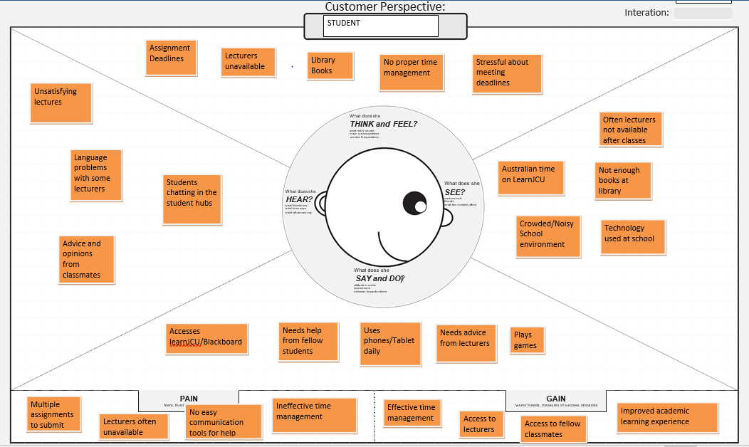

**Composite Character Profile:**

Name: Theresa

Age: 20

Occupation: student, Business Minor

Theresa is from China. She moved to Singapore for her studies. Messy lifestyle. First year at school / unable to keep up with the existing technologies. She wants to organize her time properly at school. She is missing important deadlines because of the lack of a proper schedule.

**Point-of-view madlib:**

1. The user needs to communicate with the lecturers for guidance, but cannot do that because the lecturers are not always available at school and the only communication possible is through emails.
2. The user needs to keep track of the due dates because they have to submit the assignments on time, but they find it hard to do that because they have to work on multiple assignments at the same time, and there are no notifications available from the school website.
3. The user needs a study space at school after the classes but cannot have that because the student hub is always noisy, and the library is mostly full all the time.
4. The user needs to communicate with his classmates but cannot do that because there is no proper communication channel available in the school website and the user doesn’t want to use other social media for academic purposes.
5. The user needs to use technology at their disposal in order to keep track of their time schedules.
6. The user needs access to books at the library but cannot do that because of the lack of availability of books.

**Point-of-view want ad:**

“Ambitious young student seeks for proper time management solutions to enhance her learning experience at school which she finds hard at the moment since there are many assignments to be submitted at the same time and she does not yet have a proper overview and time management. “

**List of possible topics (“How might we?”):**

|  |  |  |
| --- | --- | --- |
|  | Topic | Suggested by |
| 1 | How might we help the students solve the language barrier problems they face at school? | Robert |
| 2 | How might we provide the students a proper study space after the school hours? | Robert |
| 3 | How might we help the students communicate with the lecturers after the classes? | Udaya |
| 4 | How might we help the students improve their communication options with their fellow classmates for academic purposes? | Udaya |
| 5 | How might we help the students have more clarity when using the applications like LearnJCU, Blackboard? | Cecelie |
| 6 | How might we help the students meet their deadlines on the assignments in an effective manner? | Cecelie |
| 7 | How might we help the students have access to more books at the library? | Frederike |
| 8 | How might we help the students plan their work schedules in an efficient manner? | Frederike |

**Ideation:**

During the ideation stage of the design thinking process, we concentrated on the idea generation rather than trying to understand the user’s needs, it basically is the transition phase from simply identifying problems This will later serve as the foundation for building and developing the prototype(s) later on. As a group, we did a lot of brainstorming with the topics and ideas which emerged from the emphasizing and defining stage, listed all the possible options (see below) and started to discuss in what means this particular option would be feasible under the given circumstances and in what ways a solution out of this idea would solve the problems raised by the interviewed JCU students.

Since the challenge is to create “wearable technology” we created an overview about the kinds of wearable technologies which are already existing and in what matters we could use them for a JCU student. The most common and widely known are smart watches, smart glasses or various smart clothing items (e.g. a dress that lights up when a phone call comes in). After several discussions the group decided to design a smart watch for the students because this would, in the group’s opinion, be the most suitable solution for a student. Glasses or clothes will not be a wearable solution for everybody since students who already need glasses or who want to wear sunglasses outside. Clothes would be too much of an intervention into the student’s personal privacy.

Afterwards, we took another close look on the list of possible topics we created earlier (“How might we?”) and eliminated the particular topics we now deemed unsuitable for the design challenge. In this process, we chose the following possible topics to be taken under further examination. Possible topics 3, 4, 6 and 8:

* Topic 3: How might we help the students communicate with the lecturers after the classes?
* Topic 4: How might we help the students meet their deadlines on the assignments in an effective manner?
* How might we help the students meet their deadlines on the assignments in an effective manner?
* How might we help the students plan their work schedules in an efficient manner?

We as a group felt rather strongly that these are the issues which play an important role in preventing the students to successfully complete their studies and furthermore, that these were the problems, which we could tackle with this challenge (e.g. the language or accent difficulties which stand in the way of proper communication between teachers and students or in between student’s will not realistically be solvable with wearable technology).

As mentioned, these topics combine all of the issues mentioned by the students. We decided, to create a single solution for all of these topics and, brought together with the decision earlier of designing a smart watch, we concluded at designing a smart watch for JCU students which would integrate solution features for the topic issues mentioned above (3, 4, 6, 8).

The group’s initiative was to design a user friendly, easy to handle interface with multiple features for the user to which he will have access to. These features will (amongst others) include a planner, timetable, communication options and a notification option which will notify the user, in our case specifically the student, about the various academic deadlines and their (personalized) timetable.

**Prototype and Test (Iteration 1):**

We conducted 3 user tests on the first iteration by showing the user the prototype and asking them to use it.

**Testing 1:**

**What did the participant value the most?**

The participant was impressed with so many features included in the prototype, especially the timetable and deadline features combined in one convenient app was highlighted by the user.

**What got them excited?**

The feature for assignment deadlines got them excited.

**What would convince them about the idea?**

The idea to have a smart watch that provides a linkage to the mobile phone sounded plausible to the user. The user wanted to keep track of the various assignment deadlines since he was missing out on them. He felt the smart watch will fulfil his requirements.

**Testing 2:**

**What did the participant value the most?**

The user was extremely impressed with the timetable feature. He believes that it will help them organize the time at hand better than before.

**What got them excited?**

The user was pleased with the assignments deadlines feature.

**What would convince them about the idea?**

Having a timetable feature will make a useful device for him to use and to organize his time schedules.

**Testing 3:**

**What did the participant value the most?**

The user was extremely impressed with the communications features available in the device. They had prior troubles communicating with the lecturers and students after the class hours.

**What got them excited?**

Everything about the prototype got them excited. To have a smart watch that addresses their basic needs sounded exciting to them.

**What would convince them about the idea?**

To have a smart watch that includes useful features sounded possible to the user. He believes they can implement these features like Timetables and Deadlines to organize his work properly.

**User Inputs:**

**Which parts would participants like to improve?**

During the testing the usersuggested a few improvements that are listed below.

Tester 1:

1. The user wanted the Contacts page to include e-mail and phone number.
2. The user wanted the notifications to show up for “Deadlines” and “Communications”.

Tester 2:

1. The user said that since the size of the device is small if there were different colors used to highlight important information it will be helpful to spot them easily.
2. The user said that there was no feature to support voice dictation during communication. The only feature available was sending voice messages.

Tester 3:

1. The tester wanted to go back to the main page but there was no button for it.
2. The first prototype was missing some of the settings features which the user was unable to access.

**What did not work?**

The overall inputs from the testers have been satisfactory. A couple of testers were unimpressed with the basic color palette. They were unable to differentiate between certain settings. The settings page was missing from the prototype. There was no return button to the home page.

**What needs further investigation?**

We need to add notifications to help the user keep track of all the important notifications and communications received.

**How to integrate feedbacks and insights in the prototype in the next iteration?**

Based on the user insights, the contacts page will be updated with new features like adding email and phone number. The “notifications” page will be added to display before the home page to remind the user of any notifications they receive. Different colors will be used to highlight different information. A Voice recognition enabler will be integrated into the device to allow the user with more options while communicating. A home button will be implemented along with added features in the settings page.











**Prototype and Test (Iteration 2):**

**How to integrate feedbacks and insights in the prototype in the next iteration?**

The changes we made for iteration 2 were to add colours and notification into the menu. Battery icon that tells how much charge the smart watch has left, is placed in the top right corner in every page of this app. In the calendar feature, we added the opportunity to pin (e.g. highlight) the events that the user deems most or more important than others. We turned the voice messages into dictation messages and added a writing box that notes down the sayings. Icons that accentuate the professors were added into the right sides of the contacts so that the user (student) is aware of who in his contacts is the teacher for his or her particular subjects and who are his fellow classmates. We also added headings for e-mail and phone number to the contact feature. The setting slides were added, such as: the setting menu, language, brightness & text and volume.

**What did participants value the most?**

The participants valued the notifications that we added into the menu, along with the opportunity to pin the important events in the calendar. These two new features are linked together, and give the users notifications when the nearest pinned events are coming up.

**What would convince them about the idea?**

Just as in Testing 1, the user was happy to have all the important aspects for their student life combined in one place. As they reported, it would be much easier to coordinate all the necessary tasks.

**Which parts would participants like to improve?**

As mentioned, the participants would like to improve the colour scheme since there were difficulties in identifying the different features. Additionally, the opportunity to highlight important events in the calendar was added, as well as the distinction between a teacher and a student in the contact menu.

**What did not work?**

We were missing the battery display which will be added in the next iteration. Otherwise, we only received feedback to improve existing things but not feedback about anything which would be a complete showstopper.

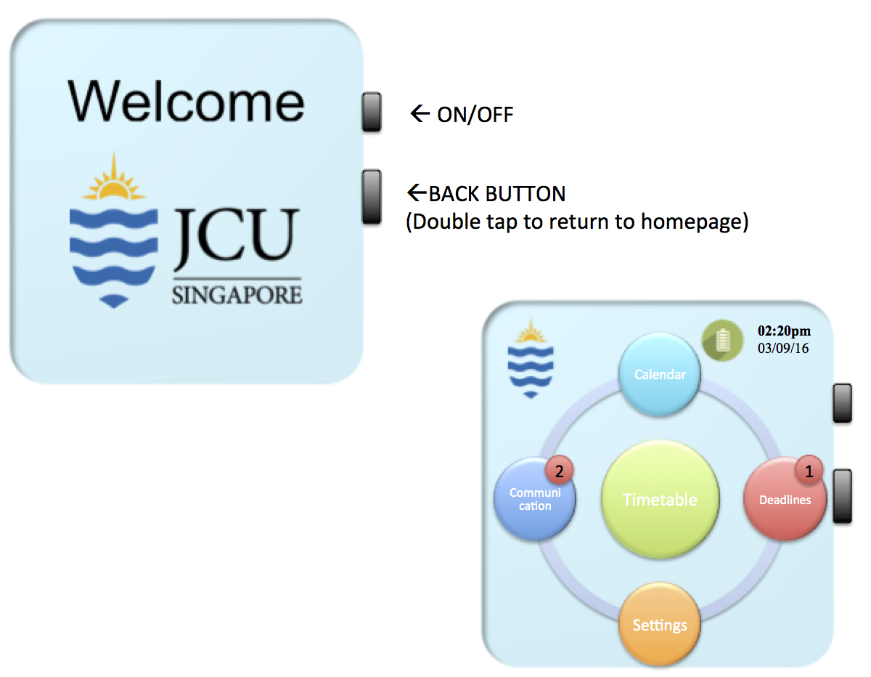

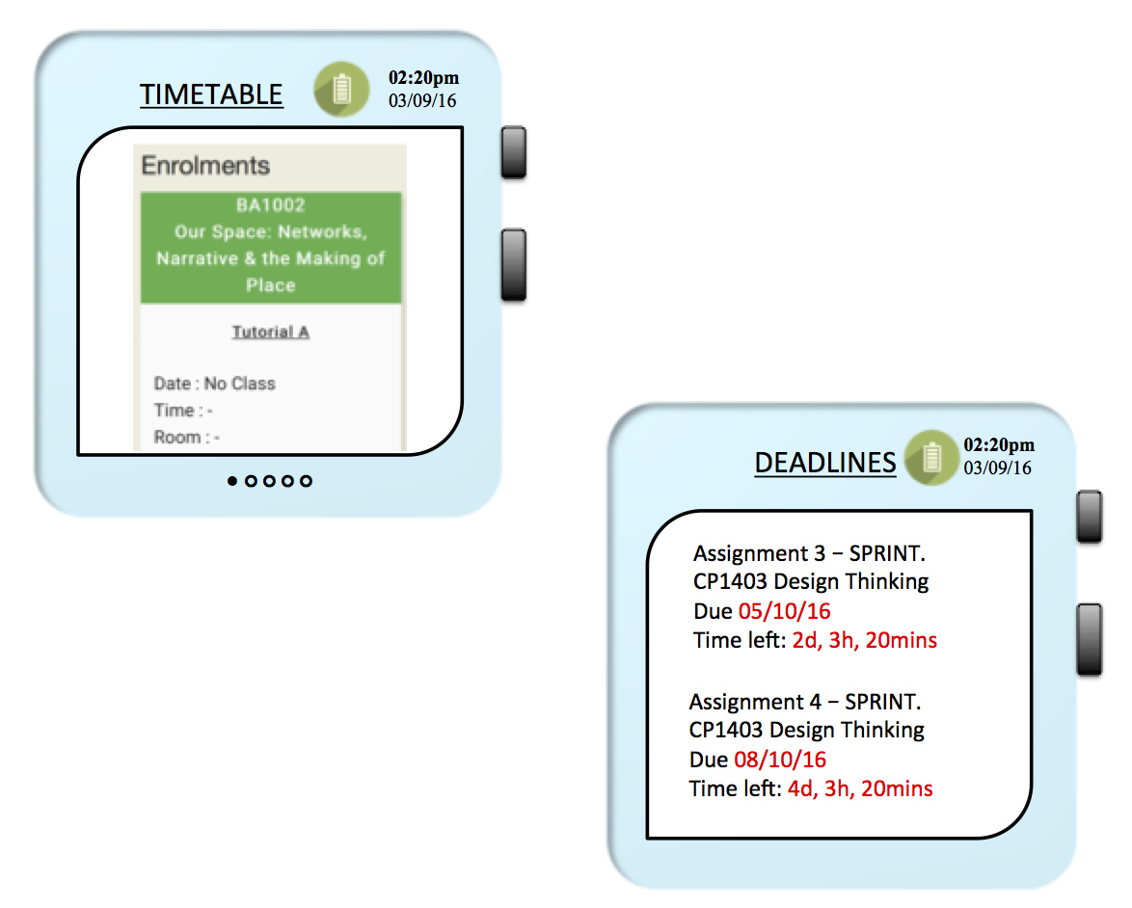

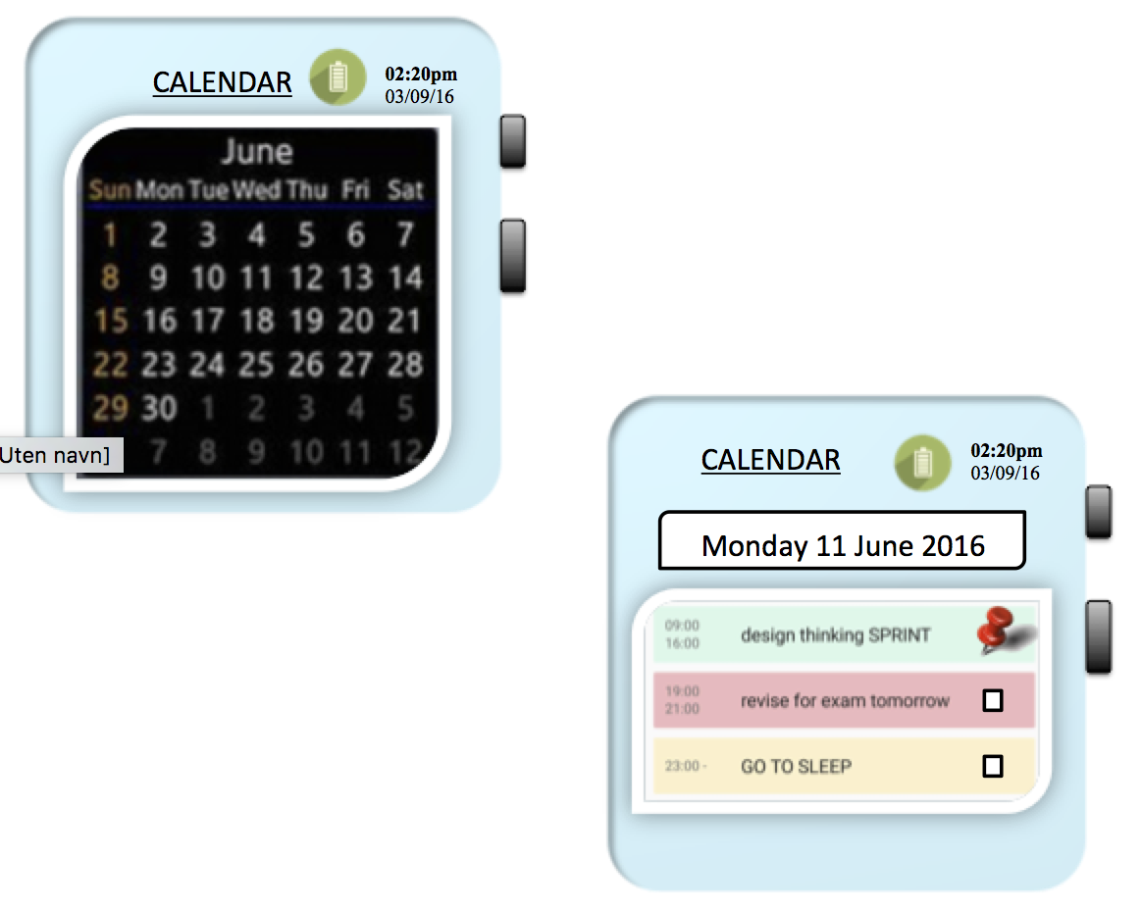

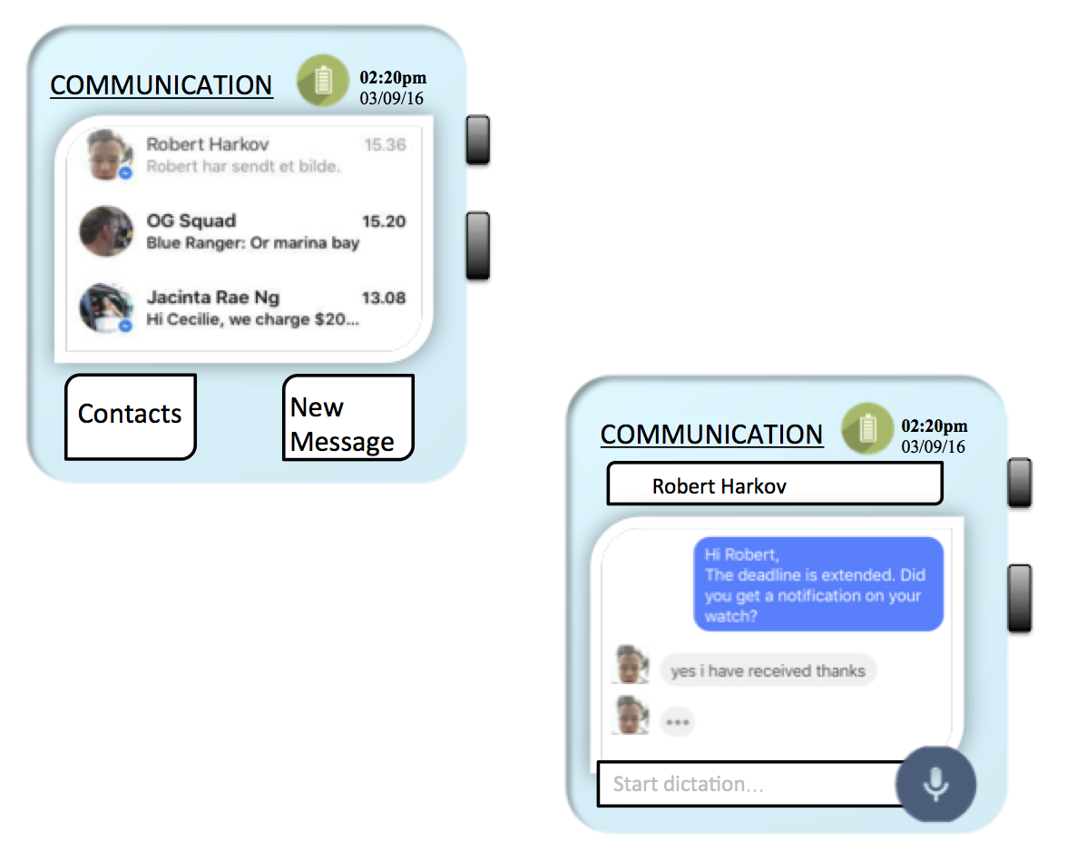

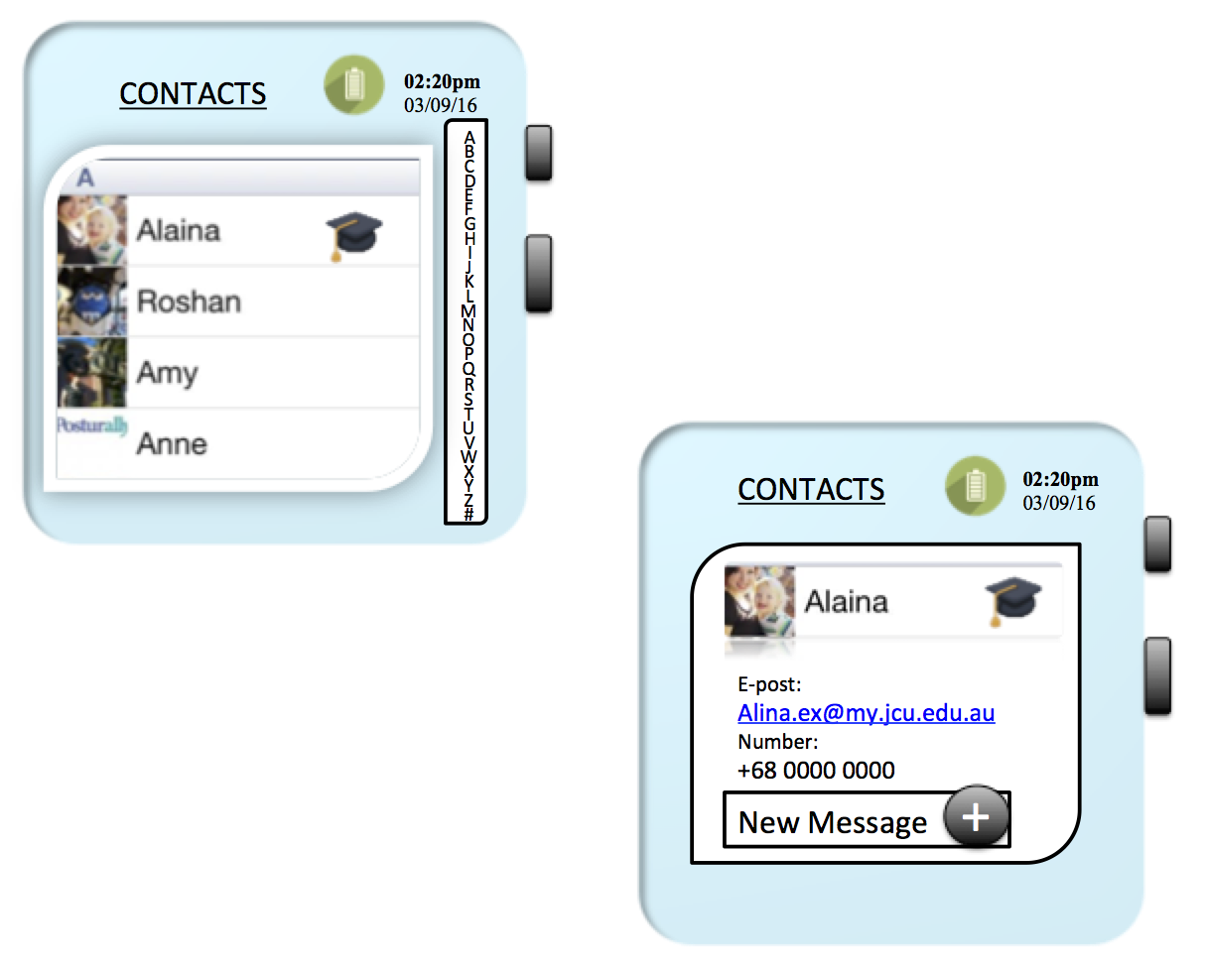

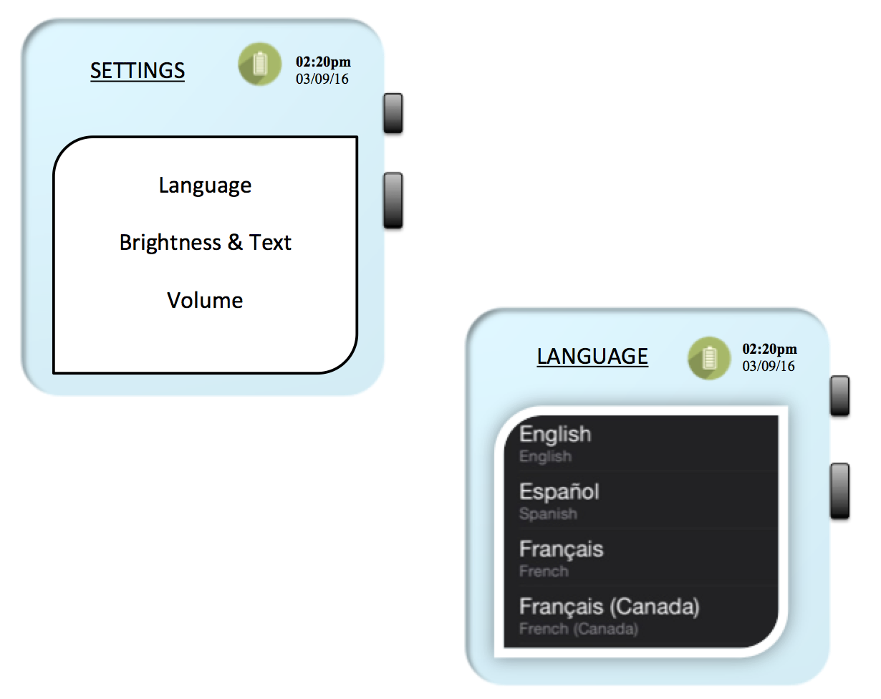

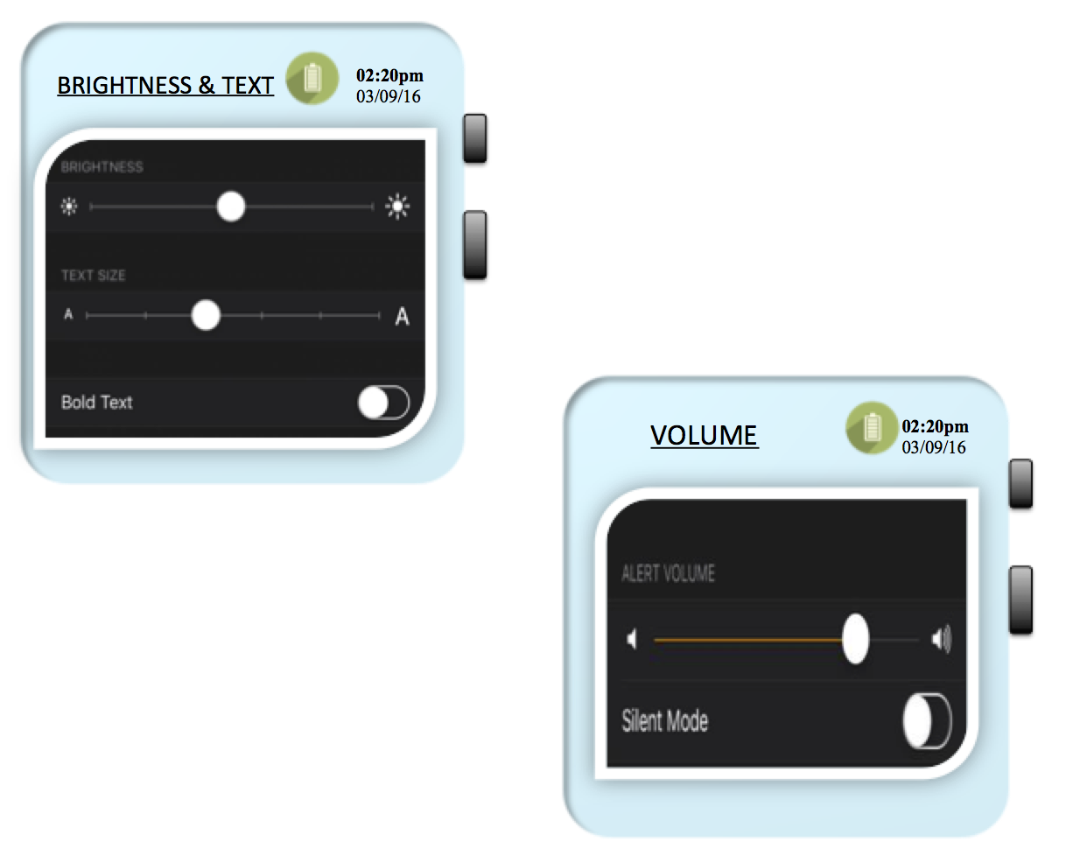

**Prototype and Test (Iteration 3):**

The major changes we made for iteration 3 were to change the whole blue theme into black/dark. We added new slides/pages such as: lock screen and notification screen that appears in the lock screen. Another big change we made was to redesign and develop the menu in settings. New features such as: Volume & Bluetooth and Color were added. Bluetooth and it’s on/off button were added into the Volume-tab. Additional side to Communication-page was also added. These were the biggest changes we have done. The minor ones are that tick boxes were added into Deadlines and the dates that has been pinned by the user is framed in the overview of the calendar.

**What did participants value the most?**

The participants valued the lock screen and the notifications that come with it.

**What got them excited?**

They got excited about the new design of the app. This is a less intense colour, and gives a relaxing feeling when watching it. They also got excited about the opportunity to customise the colours that is used to indicate the notifications in the lock screen and the home screen icons.

**What would convince them about the idea?**

As before, the users were pleased with having all the important items in order to successfully complete their semester conveniently in one place.

**Which parts would participants like to improve?**

The participants were mostly pleased with this product, but an improvement that was suggested was to add a GPS feature.

**What did not work?**

There was suggested adding a GPS feature in order for the students to look up if they happen to be confused about the way, but the group decided to leave this out.

**What needs further investigation?**

The further investigation that needs to be done is the new Message.











**Images of Final Prototype:**









**Appendix:**

**Interview 1:**

Nang Ohn Shew Kyi, 20 years old

* Hello Kyi, thanks for taking the time to talk to us today. How do you like being a student at JCU? How has your experience been so far?
  + I like JCU because everything is well organized and convenient. LearnJCU is very good too, you always have easy access to subjects and your classes. But I keep forgetting my assignments because I don’t get any notifications and since there are many assignments at the same time, it is often stressful to remember everything at once. I missed two quizzes already and got a zero!
* What does a normal day at JCU look like for you?
  + Oh, it is quite simple! I didn’t join any clubs so I just come for classes and go back home.
* How was starting this semester? Did you have any difficulties in the beginning?
  + In the beginning, I was unfamiliar with the technology used here (LearnJCU and StudentFirst) and I had to get used to it. That took me like two days and even after, I had to ask my friends and even lecturers for help.

Did you have to seek a lot of help during the first week?

* + Not really, but even to this day I still don’t know many things when it comes to the various student services that the school offers. For example, I don’t know how to book rooms or check my attendance. I still need to figure that out. Even yesterday, I had to scan a few pages related to my assignment, but I didn’t know that I have to be a registered user to access the scanner. These things may sound simple, but there is no way of knowing them until you actually use them. And I believe this lack of information can be a bit of a hindrance when we are running on tight deadlines in our academic schedules.
* If you could change anything you’d like, what would it be?
  + The assessment feature at LearnJCU, since there are no notifications or anything I already missed two deadlines and had no chance of making it up. I always like to organize my things in a proper manner and it will be really helpful if they can provide me with reminders regarding my assignments.
* What other technologies do you use connected to your life as a JCU student?
  + Yes, my tablet of course for scripts and lectures and my phone. For document exchanges with my group we mostly use Dropbox and Google Drive. So far I’m happy with how things are working out.
* Alright, very good. Is there anything else you would like to add or comment?
  + No, I don’t think so.
* Thank you very much for your time Kyi!

**Interview 2:**

Ian, 18 years old

* Hello Ian, thanks for taking the time today to talk to us.
* How do you like being a student at JCU?
  + Better than I expected. The quality of school is better than I thought, for example the lecturers and the classes too.
* Tell me about your normal day?

Nothing special, just the same as any other student.

* Is there anything that bothers you?
  + Sometimes I miss classes because the lectures are too boring. Assignments are a problem, sometimes the lecturer didn’t teach us and I need the help of my friends when doing it or use google to teach myself because we didn’t learn about it in class.
* Is there anything besides classes which bothers you?
  + Student Hub is too crowded and we cannot find a seat, so we have to sit in the canteen which is not a good environment. The only place where I can find some space available

for my studies is the library, but even it is mostly full all the time. It is a bit hard for me to concentrate on my studies after I finish the lectures.

* Do you use LearnJCU?
  + Always! And Student First to check attendance.
* Have you experienced any difficulties with these two programs?
  + Australian time at LearnJCU so it sometimes is hard to know at what time we will have to submit the assignments and it is easy to forget. In fact, I made a late submission for one of my assignments and lost a few points because of this mistake.
* Can you elaborate on that please?

Oh yes, actually it was a minor error I made while checking the due date for our programming assignment. The assignment was due at 12 pm late in the night but when I checked it, the time was showing as 2 am. I didn’t know at that time that the LearnJCU uses Australian time for its updates. I forgot to check the time standard they were using. I was running late on my work and I had to make a few minor adjustments to my assignment before submission. So I submitted it an hour later at around 1 am. And I lost points for late submission.

* Oh, that’s unfortunate. Are there any other applications that you use? Have you faced any similar difficulties using them?
  + I use Blackboard on my phone, which is more convenient because I don’t have to log in to see all my information about classes etc.
* Is there anything you would like to change?
  + LearnJCU and Blackboard have basically everything I need. They could have learning support though! Learning support for my group and the class, something like a chat feature. If the LearnJCU had a communication chat, we could have the communication with our groups and classmates within the learning environment, so we don’t have to do it over Facebook or WeChat where you can easily get distracted.
* Alright Ian, is there anything else you’d like to add or comment on?
  + No.
* Thank you very much for your time. Good luck with the rest of the challenge!

**Interview 3:**

Larry, 20 years old

Course: BIT

* Hello, how are you? Thank you for giving me the time to interview you.
  + You are welcome.
* May I know your name and your course of study here at JCU Singapore.
  + My name is Larry. I am 20 years old. I am studying my bachelor’s in IT. I am from Myanmar.
* How do like being a student at JCU?
  + It’s really good. Our country doesn’t have learning materials like projectors, labs, and other technology they use here in their teaching process.
* So, the technology they use here, do you think it is better?
  + Yes, it is really helps with my studies. I am able to understand things much more clearly when I use these devices.
* What are the technological devices you use for your studies?
  + I use computers to find information. I prefer to access all my information in one device. I also use the IPAD provided by the school. I use my smart phones as well.
* How helpful are they with your studies?
  + I use the computers for my long assignments, long projects like programming and networking. I use my IPAD to read eBooks and the blackboard access to the LearnJCU, and my smart phones to check the bus timings and WhatsApp. I am not really comfortable to carry my laptop to the school daily.
* Why do you say so?
  + I want something easy to carry and that provides all the information on one single device. But I cannot do away with my computers!
* What do you mean by that?
  + I play a lot of computer games, which I cannot do on my IPAD. I play a lot of graphic intensive games which require more processing power. And since I am an IT student I have to use my laptop for most of my programming. I can use an alternative to it.
* Alternatives, like what?
  + May be something like “Windows Surface” that will help me use my tablet as a computer.
* Are there any problems you are facing in your school life?
  + No problems as such, but I am unable to keep up to the tough time schedules here. Especially during the later weeks, I have to submit multiple assignments at the same time and I am unable to keep track of all the submissions I have to make. Sometimes I forget which one is due at what time, and I become stressed in the end. It will be really helpful if there is an easier way to organize my work schedule.
* Is there anything else that bothers you?
  + Nothing much, but the library has fewer number of books than required. And the books are quite expensive here to buy, so I find it very hard to search for the right one. And they allow me to borrow the books for only a week, which in my opinion is not enough time.
* Do you use learn JCU?
  + Yes, I do, and it is really helpful. But the only problem I find with it is the assessment submission and the blackboard are used well when I access them from my computer. I just want a better Blackboard app. And I also don’t want the completed subjects to show on the menu, it makes the menu look more cluttered.
* Are there any other things you would like to add?
  + Yes, during my first weeks at school I was unable to understand some of the lecturer’s accents. But with time I got adjusted to that. I usually prefer to have direct communication with the lecturer rather than emails, but the lectures are also unavailable during a few days of the week. If there was any communication channel with the lecturers apart from mailing them, it would have helped me a lot.
* Would you like to add anything else?
  + No, nothing else comes to my mind right now. That is all for now.
* That’s fine. Thanks a lot for your time. Good luck with your Sprint.
  + Good luck to you as well.

